# Global estimation of dietary micronutrient inadequacies

Simone Passarelli1*^, Christopher M. Free2,3^, Alon Shepon4, Ty Beal5,6, Carolina Batis7, Christopher D. Golden1,8,9

1 Department of Nutrition, Harvard T.H. Chan School of Public Health, Boston, MA 02115, USA

2 Marine Science Institute, University of California, Santa Barbara, Santa Barbara, CA 93117, USA

3 Bren School of Environmental Science and Management, University of California, Santa Barbara, Santa Barbara, CA 93117, USA

4 Department of Environmental Studies, The Porter School of the Environment and Earth Sciences, Tel Aviv University, Israel

5 Institute for Social, Behavioral and Economic Research, University of California, Santa Barbara, CA ​​​​93106, USA

6 Global Alliance for Improved Nutrition, Washington, DC 20036, USA

7 Nutrition and Health Research Center, National Institute of Public Health, Cuernavaca, Morelos, Mexico

8 Department of Environmental Health, Harvard T.H. Chan School of Public Health, Boston, MA 02115, USA

9 Department of Global Health and Population, Harvard T.H. Chan School of Public Health, Boston, MA 02115, USA

**\* Corresponding author:** Office of Global Food Security, U.S. Department of State, Washington, DC 20006; [simoneapassarelli@gmail.com](mailto:simoneapassarelli@gmail.com)

^Both lead authors contributed equally to this publication.

**Keywords:** nutrition, micronutrients, usual intakes, intake inadequacy, diets, malnutrition

## Abstract

**Background**

Inadequate micronutrient intakes and related deficiencies are a major global public health challenge. Recent analyses have assessed global micronutrient deficiencies and inadequate nutrient supplies, but there have been no global estimates of inadequate micronutrient intakes.

**Methods**

We adopted a novel approach to estimating micronutrient intake that accounts for the shape of a population’s nutrient intake distribution, based on dietary intake data from 31 countries. Using a globally harmonized set of age- and sex-specific nutrient requirements, we then applied these distributions to publicly available data for 185 countries from the Global Dietary Database on modeled median intakes of 15 micronutrients for 34 age-sex groups to estimate the prevalence of inadequate nutrient intakes for 99.3% of the global population.

**Findings**

Based on estimates of nutrient intake from food (excluding fortification and supplementation), over five billion people do not consume enough iodine (68% of global population), vitamin E (67%), and calcium (66%). Over four billion people do not consume enough iron (65%), riboflavin (55%), folate (54%), and vitamin C (53%). Estimated inadequate intakes were higher for women than men for iodine, vitamin B12, iron, and selenium and higher for men than women for magnesium, vitamin B6, zinc, vitamin C, vitamin A, thiamin, and niacin, within the same country and age groups.

**Interpretation**

This analysis provides the first global estimates of inadequate micronutrient intakes using dietary intake data, highlighting highly prevalent gaps across nutrients and variability by sex. These results can be used by public health practitioners to target populations in need of dietary interventions.

**Funding**

Simone Passarelli was supported by National Institutes of Health (NIH) Training Grant

2T32DK007703-26 in Academic Nutrition. Ty Beal was supported by contributions from the Dutch Ministry of Foreign Affairs. No funder played any role in this research.

## 

## 1. Introduction

Micronutrient deficiencies are one of the most common forms of malnutrition globally.[1,2](https://www.zotero.org/google-docs/?2wl3Bi) A key pathway to micronutrient deficiencies is through inadequate intake of essential nutrients like iron, zinc, vitamin A, iodine, and folate, among others, with deficiency in each nutrient carrying its own public health consequences. Iron deficiency is the most common cause of anemia, leading to impaired cognition and adverse pregnancy outcomes.[3](https://www.zotero.org/google-docs/?fH3Tiq) Vitamin A deficiency is the leading cause of preventable blindness globally. Both vitamin A and zinc play a critical role in immunity, especially for populations facing a high burden of infectious diseases.[4,5](https://www.zotero.org/google-docs/?thLVTB) Folate is needed early in pregnancy to prevent stillbirths and neural tube defects, and iodine is essential for pregnant and breastfeeding women due to its role in fetal and child cognitive development.[6](https://www.zotero.org/google-docs/?QR1C5z)

Deficiencies in these micronutrients and others collectively contribute to a large burden of morbidity and mortality, but the scale and demographic specificities of the problem are unknown due to limited data.[1,7](https://www.zotero.org/google-docs/?svCAmA) The global prevalence of micronutrient *deficiencies* using clinical nutritional biomarkers has been estimated for select populations and micronutrients;[1,8](https://www.zotero.org/google-docs/?9B9EkT) however, substantial data gaps persist for various micronutrients, specific population groups (especially males), and many geographies. Existing data are also often outdated. The global prevalence of inadequate micronutrient *supplies* using food availability data has also been estimated, which highlights inadequacies in the food supply.[9,10](https://www.zotero.org/google-docs/?iV5k1U) Due to scarce quantitative dietary intake data and no suitable approach to accurately model nutrient intake distributions, there have been no global estimates of inadequate micronutrient *intakes*. Estimates of micronutrient deficiencies, inadequate micronutrient intakes, *and* inadequate micronutrient supplies are all required to have a comprehensive understanding of the burden of micronutrient malnutrition.

To tackle such a large-scale public health crisis, estimates are needed to identify which nutrients pose the greatest risk, where, and to whom.[11](https://www.zotero.org/google-docs/?h0Aszy) While micronutrient deficiencies are presumably widespread, we have only limited data on women and children. A pooled global analysis of biomarker data found over 1 in 2 children under age five are deficient in either iron, zinc, or vitamin A, while 2 in 3 women aged 15–49 years are deficient in either iron, zinc, or folate. However, there are no recent, global, population-wide estimates of nutrient deficiencies for a wider range of micronutrients.[1](https://www.zotero.org/google-docs/?ZzeChn)

The Global Burden of Disease (GBD) study examines the burden of micronutrient malnutrition in 195 countries using a modeling approach combining clinical outcomes (e.g., goiter), biomarkers of micronutrient status (e.g., serum retinol) and anemia (e.g., hemoglobin concentration), and inadequacy in the food supply (e.g., zinc inadequacy).[12](https://www.zotero.org/google-docs/?T68mp0) They only include estimates of disease for four micronutrients (iodine, iron, zinc, and vitamin A) due to scarce data[12](https://www.zotero.org/google-docs/?aZ4hyg); yet, there are 29 known essential micronutrients.[13](https://www.zotero.org/google-docs/?dqHMES) While their modeling approach may be generated using the best available methods and data, the gaps in micronutrient status biomarkers and dietary intake data hinder the ability to comprehensively model micronutrient malnutrition. Furthermore, the GBD study’s approach to modeling micronutrient malnutrition is not replicable because their data, methods, code, and assumed nutrient distribution shapes are not publicly available.[14](https://www.zotero.org/google-docs/?RZSbEa)

Although nutritional biomarkers provide the best indication of nutritional deficiencies, these deficiencies may be caused by a constellation of factors including inadequate dietary nutrient intake, infectious diseases, or absorption issues. Therefore, the best way to identify at-risk populations of diet-related malnutrition is to estimate inadequate nutrient intakes. Previous studies have estimated micronutrient adequacy of the food supply.[9,10,15–17](https://www.zotero.org/google-docs/?AGnQ87) Some of these studies have used terminology to imply that these estimates reflect nutrient intakes, including “*estimated* prevalence of inadequate intakes”,[10](https://www.zotero.org/google-docs/?AUzgre) “*risk* of inadequate intake”,[10](https://www.zotero.org/google-docs/?8DmQrK) and “*apparent* consumption”.[18](https://www.zotero.org/google-docs/?LxOxmH) This may have inadvertently led to confusion that global estimates of inadequate nutrient intakes already exist. However, nutrient adequacy estimates relying on food supplies do not account for household food waste, food service waste, small-scale food production, or wild harvest, and they have no information on how food is allocated across each country’s population (i.e., there is no information for specific demographic groups like sex or age groups). Due to these limitations, supply-based estimates are inaccurate, tending to underestimate inadequacy in high-income countries and overestimate it in many low- and middle-income countries.[19](https://www.zotero.org/google-docs/?AM9a85)

In contrast to studies relying primarily on food supplies, the Global Dietary Database (GDD)[20](https://www.zotero.org/google-docs/?WXNviy) provides the only estimates of micronutrient *intakes*, using data from individual dietary intake surveys, household surveys, *and* national food supplies.[21,22](https://www.zotero.org/google-docs/?3m3kYp) For 10 years, the GDD has standardized and compiled individual-level dietary datasets from 185 countries for over 50 foods, beverages, and nutrients[20,22](https://www.zotero.org/google-docs/?2pS04S), providing the best available data to understand the amount of nutrients actually *consumed* by individuals, rather than *available* for consumption. However, the GDD does not estimate micronutrient intake distributions or micronutrient requirements, which are needed to accurately estimate the prevalence of inadequate micronutrient intakes.

This manuscript provides a novel and reproducible approach to estimating the global prevalence of inadequate micronutrient intakes by accounting for the shapes of nutrient intake distributions and using globally harmonized nutrient reference values. We seek to identify dietary nutrient gaps in specific demographic groups and countries, as well as estimate the total global burden of dietary micronutrient inadequacies for 15 essential micronutrients. Once these micronutrient shortfalls are identified in global diets, this information can enable implementation partners, public health practitioners, and policy makers to prioritize interventions that will address these gaps in dietary micronutrient intake.

## 2. Methods

### 2.1 Overview

We estimated intake inadequacies for 15 micronutrients (**Table S1)** across 34 subnational age-sex groups in 185 countries. This approach required understanding nutrient intake and requirement distributions for every subnational population globally (**Figure 1**). We developed these subnational nutrient intake distributions using estimates of (1) distribution scale (i.e., intake median) from the Global Dietary Database and (2) distribution shape (i.e., intake variability) from the nutriR database (**Figure 1A**).[23](https://www.zotero.org/google-docs/?Kuv8i5) We then developed subnational nutrient requirement distributions using the harmonized average requirements defined by Allen et al.[24](https://www.zotero.org/google-docs/?EUtUCH) and common assumptions about the levels of requirement variability (**Figure 1B**). We used the probability method[25](https://www.zotero.org/google-docs/?nIH4u4) to calculate intake inadequacies by comparing the derived intakes against the requirement distributions (**Figure 1C**) and calculated the number of people with intake adequacies using subnational human population size estimates from the World Bank.[26](https://www.zotero.org/google-docs/?bQ0PfV) All analyses were done using R[27](https://www.zotero.org/google-docs/?ubrWwA) and all data and code are available on GitHub: <https://github.com/cfree14/global_intake_inadequacies>. An interactive R Shiny web application for exploring the results in detail is available here: <https://emlab-ucsb.shinyapps.io/global_intake_inadequacies/>. No funder played any role in this research.

### 2.2 Defining subnational populations

Using World Bank definitions, we estimated human population size within 34 age-sex groups (males and females in 17 age groups: 0- to 80-yrs-old in 5-yr groups, plus an 80+ age group) for 218 countries or territories.[26](https://www.zotero.org/google-docs/?1gn0kU) We refer to these country-age-sex groups as subnational populations throughout this paper. We used estimates for 2018, when the global population was approximately 7.57 billion people (**Figure S1)**, given that this is the most recent year with GDD data (described below). The 185 countries with GDD data encompass 7.52 billion people (99.3% of the global population).

### 2.3 Defining subnational intake medians

We developed subnational nutrient intake distributions with median intakes equivalent to the estimates provided in the Global Dietary Database (GDD).[20,21](https://www.zotero.org/google-docs/?XJjQYr) The GDD uses datasets from household surveys and food balance sheets to estimate the median intake of 17 micronutrients from 19 food and beverage categories (**Table S2**) by subpopulation in 185 countries from 1990-2018 (5-yr intervals 1990-2015). Subpopulations are defined by 44 age-sex groups, three levels of education (i.e., low, medium, and high), and two areas of residence (i.e., rural and urban). We excluded two nutrients from the analysis: (1) potassium, which does not have accepted average requirement levels, and (2) vitamin D, which is highly geographically variable because the average requirement levels can be met through sun exposure rather than dietary intake.[28](https://www.zotero.org/google-docs/?yZvupo) This leaves 15 micronutrients (9 vitamins and 6 minerals) available for analysis (**Table S1)**. We defined median intakes for each age-sex group using the GDD-provided average across areas of residence and levels of education. We then averaged these intake estimates to match the 34 age groups used in the Word Bank human population data following **Table S3**. Finally, to account for the supply of calcium and magnesium in drinking water, we assumed that all people consume their daily adequate intake of drinking water and that this water has an average concentration of 46 mg of calcium and 16 mg of magnesium per liter. Age- and sex-specific adequate intakes are from IOM[29](https://www.zotero.org/google-docs/?cSk2z1) and calcium and magnesium concentrations are the average of global water sources from WHO[30](https://www.zotero.org/google-docs/?oD1s6O).

### 2.4 Defining subnational intake shapes

We defined the shape of each subnational nutrient intake distribution using estimates of subnational nutrient intake shapes provided in the nutriR database.[23,31](https://www.zotero.org/google-docs/?HLKY9B) Passarelli et al.[23](https://www.zotero.org/google-docs/?dPR9v5) assembled a database of dietary recall surveys from 31 countries and used this database to construct statistical distributions -- either log-normal or gamma distributions -- that describe usual intakes for 51 nutrients. The 31 countries were selected for inclusion based on whether there was an available dataset with (1) individual-level dietary data, (2) calculated nutrient-level data, (3) ≥2 days of dietary intake (for at least some participants), (4) data based on a 24-hour recall or diet record/food diary, and (5) a sample size >200 people.[23](https://www.zotero.org/google-docs/?4JR5Aa) Due to limitations in the coverage of dietary recall surveys, distribution shapes are not available for all subnational groups, even within the 31 countries with data. Thus, we matched every subnational group evaluated in this paper with the shape parameters of the most similar subnational group with data. We performed this matching with preference for shape parameters from: (1) the actual subpopulation (“known”); (2) the nearest age-group within the country and sex (“nearest age group”); (3) the corresponding age-group from the opposite sex within a country (“opposite sex”); and (4) the corresponding age-sex group from the country with the most similar nutrient intakes to the country of interest (“most similar country”). We identified the country with the most similar nutrient intakes to the country of interest as the country with the smallest Euclidean distance in a dissimilarity matrix computed using the 2018 national nutrient intakes estimated in the GDD (**Figure S2**); in other words, the country with the most similar nutrient intakes in multivariate space. **Figure S3** illustrates the extent and sources of borrowed shape information.

### 2.5 Defining subnational intake distributions

We specified the final usual intake distribution for each subnational group using its median value and matched shape parameters (**Figure 1A**). The matched shape parameters describe the variability of each distribution but produce different medians than those prescribed by the GDD estimates. Therefore, we shifted the shape parameters to match the GDD median while maintaining the variability described by the matched shape parameters. For intake distributions parameterized using a log-normal distribution, we maintained the variability parameter, *σ*, and shifted the centrality parameter, *µ*. For intake distributions parameterized using a gamma distribution, we maintained the variability parameter, *α*, and shifted the centrality parameter, *β*. The shifted parameters were derived analytically for the log-normal distribution and numerically for the gamma distribution using the *shift_dist()* function in the *nutriR* package.[31](https://www.zotero.org/google-docs/?4nWweg) See **Figure S4** for a conceptual illustration of these distribution shifts.

### 2.6 Estimating subnational intake inadequacy

We estimated the prevalence of intake inadequacy, also known as summary exposure value (SEV), using the probability method[25](https://www.zotero.org/google-docs/?tPSsRz) as implemented in the *nutriR* package.[31](https://www.zotero.org/google-docs/?fz4OWK) The probability method compares intake distributions against a continuous relative risk curve with a value of 1 at low intakes, 0.5 at the average intake requirement, and 0 at large intakes (**Figure 1C**). These risk curves are defined based on the cumulative normal distribution described by the average requirement and its standard deviation (**Figure 1B**). We used the harmonized age- and sex-specific average requirements (ARs) provided by Allen et al.[24](https://www.zotero.org/google-docs/?xarpdY) as the average requirements for this analysis (**Figure S5**). We assumed a coefficient of variation (CV) of 0.25 for the requirement of vitamin B12 and 0.10 for the requirement of all other distributions based on the recommendation of Renwick et al.[32](https://www.zotero.org/google-docs/?e81XQN). The CV is used to derive the standard deviation of the requirement distribution.

We further specified country-specific ARs for zinc and iron based on dietary factors that inhibit or enhance their absorption (**Figure S6 & S7**). First, phytate inhibits zinc and iron absorption,[33](https://www.zotero.org/google-docs/?Gxr9HN) which means that ARs for zinc and iron increase with higher phytate intakes.[24](https://www.zotero.org/google-docs/?abLvZr) Second, non-dairy animal-source food consumption enhances iron absorption,[34](https://www.zotero.org/google-docs/?ve90oD) which means that ARs for iron decrease with higher non-dairy animal-source food (ASF) intakes.[24](https://www.zotero.org/google-docs/?dVHQD6) While calcium absorption is also impacted by dietary factors such as phytate, oxalate, and dairy intake, we were unable to account for these impacts given a lack of data on global oxalate intakes, which are the dominant factors impacting calcium absorption.[35](https://www.zotero.org/google-docs/?RGY5dH)

We derived country-specific ARs for zinc based on average country-level estimates of phytate intake from Wessels and Brown[36](https://www.zotero.org/google-docs/?lhlTWv) (**Figure S8**) by linearly interpolating between the lowest AR and lowest phytate intake and the highest AR and highest phytate intake within each age-sex group (**Figure S6**). We derived country-specific ARs for iron accounting for the joint impacts of phytate and non-dairy ASF on iron absorption using a procedure similar to Beal et al.[10](https://www.zotero.org/google-docs/?mFAXzG) First, we scaled the country-level phytate intakes (**Figure S8**) between 0 and 1, where 0 indicates low iron absorption (high phytate intake) and 1 indicates high absorption (low phytate intake). Then, we scaled country-level estimates of non-dairy ASF intakes (i.e., sum of seafood, processed meat, unprocessed red meat, and egg intakes; unprocessed poultry meat is excluded because it is not available in the GDD; **Table S2; Figure S9**) from the GDD[20](https://www.zotero.org/google-docs/?2SRUCw) between 0 and 1, where 0 indicates low iron absorption (low non-dairy ASF intake) and 1 indicates high absorption (high non-dairy ASF intake). Next, we averaged these two indicators to create a single absorption index, where lower values indicate lower absorption and higher values indicate higher absorption, and scaled these averages between 5% and 16% absorption, the range of real-world iron absorption levels[24](https://www.zotero.org/google-docs/?5SgaUf) (**Figure S10**). Finally, we derived the absorption-specific ARs by linearly interpolating between the ARs specified by Allen et al.[24](https://www.zotero.org/google-docs/?jqzJ8N) (**Figure S7**).

We calculated the number of people within each subnational group with inadequate intakes as the product of the number of people and prevalence of inadequate intakes in the group.

## 3. Results

Inadequate intake estimates were generally high (**Figure 2**) and especially common for iodine (5.1 billion people; 68% of the population), vitamin E (5.0 billion people; 67% of the population), calcium (5.0 billion people; 66% of the population), and iron (4.9 billion people; 65% of the population). Niacin exhibited the lowest level of inadequate intake (1.7 billion people; 22% of the population) followed by thiamin (2.2 billion people; 30% of the population) and magnesium (2.4 billion people; 31% of the population) (**Figure 2**). A few countries exhibited estimated intake inadequacies that diverged from the general patterns. For example, India exhibited especially high estimated inadequate intakes of riboflavin, folate, vitamin B6, and vitamin B12; Madagascar and the Democratic Republic of the Congo exhibited higher inadequate niacin intakes; and Russia, Mongolia, and Kazakhstan exhibited higher inadequate selenium intakes (**Figure 2**).

Calcium intake inadequacy was highest in countries in South Asia, Sub-Saharan Africa, and East Asia and the Pacific (**Figure 3**). Intake inadequacy was high across all age-sex groups in these countries, but especially among 10–30 year-olds. Only countries in North America, Europe, and Central Asia exhibited consistently low prevalence of inadequate calcium intakes (**Figure 3**). Low prevalence of inadequate iodine intakes were only observed in Europe, New Zealand, and Australia (**Figures 2 & 3**), and for vitamin E, in Pacific Island countries (**Figures 2 & 3**). For riboflavin and vitamin B12, high prevalence of inadequate intakes were only common in countries in South Asia (**Figures 1 & 2**).

Globally, the prevalence of inadequate intakes was consistently higher for females than for males in the same country and age group for iodine, vitamin B12, iron, and selenium (**Figure 4**). The prevalence of inadequate intakes was higher for females than males in most regions for calcium, riboflavin, vitamin E, and folate. Conversely, the prevalence of inadequate intakes was consistently higher for males than females in the same country and age group for magnesium, vitamin B6, zinc, vitamin C, vitamin A, thiamin, and niacin (**Figure 4**).

## 4. Discussion

This analysis provides a new, replicable, and accessible methodology for estimating micronutrient intake inadequacy. Globally, we found that more than five billion people do not consume enough of each of three nutrients–iodine, vitamin E, and calcium. Over four billion people do not consume enough of each of another four nutrients–iron, riboflavin, folate, and vitamin C. Our analysis demonstrates that the majority of the global population has inadequate micronutrient intake.

Globally, we found that women faced a higher prevalence of inadequate intakes relative to men for iodine, vitamin B12, iron, selenium, calcium, riboflavin, and folate. Conversely, there are several nutrients for which men have higher intake inadequacies compared to women, including magnesium, vitamin B6, zinc, vitamin C, vitamin A, thiamin, and niacin. Many of the differences observed may relate to a combination of differing dietary patterns between sexes, dietary requirements, and consumption quantities.

This paper builds on work that estimates the global prevalence of micronutrient deficiencies and inadequate nutrient supplies. Stevens et al.[1](https://www.zotero.org/google-docs/?iH0Cjl) assessed micronutrient deficiency based on biomarker data for all datasets available globally (24 nationally-representative datasets) for non-pregnant women and preschool aged children, estimating that over half of preschool-aged children and two-thirds of non-pregnant women have micronutrient deficiencies. Our estimates generally show a higher prevalence of intake inadequacy compared to their biomarker data. One reason for this difference might be that our estimates do not include supplements and fortified foods, so our estimates are reflective of nutrient adequacy from unfortified foods. Additionally, nutritional deficiencies, as measured by clinical biomarkers, although highly correlated with nutrient intake,[37](https://www.zotero.org/google-docs/?maDYP0) may be strongly influenced by disease status, inflammation, microbiome, and other contextual factors. Though many analyses have modeled inadequate nutrient supplies, ours is the first analysis to estimate global inadequate intakes by applying nutrient intake distributions to estimated intake data using age- and sex-specific intake distributions

## 5. Limitations

Our analysis is subject to limitations–most notably, data availability (**Table S4**). There remains a lack of individual dietary intake data worldwide, especially nationally representative datasets and datasets with two or more days of intake. Although GDD coverage has grown to include >99% of the global population and become more precise over time,[20](https://www.zotero.org/google-docs/?01dDa8) recent nationally representative quantitative dietary intake data is scarce, which limits the ability to validate the modeled estimates across countries.[38](https://www.zotero.org/google-docs/?rqQ92e) This also limited the number of statistical distributions that could be estimated in the nutriR database. By basing the global intake distribution shapes on datasets from only 31 countries, it is possible that some of the distribution shapes were incorrectly estimated, resulting in inaccurate estimates of inadequacy.

The estimates presented in this paper are of inadequate nutrient intake and do not include information on fortification or supplementation. In essence, this means that our inadequate intake estimates likely overestimate risk for some key nutrients (e.g., iodine) in particular locations. Nonetheless, there is limited supplementation and fortification with many of these micronutrients globally.[39](https://www.zotero.org/google-docs/?5YZvX6) Among countries with available Demographic and Health Survey data, which operates in 90+ developing countries, supplementation for select demographic groups is somewhat common for iron, with 32% of pregnant women consuming iron for >90 days of their pregnancy, and 14% of children consuming a supplement in the previous week.[40](https://www.zotero.org/google-docs/?ttMWCH) Supplementation is the highest for vitamin A in children; an estimated 55% have had a high-dose vitamin A supplement in the previous six months.[40](https://www.zotero.org/google-docs/?wROkYo) There is inadequate data on fortification for most nutrients except iodine; UNICEF estimates that 89% of people worldwide consume iodized salt.[41](https://www.zotero.org/google-docs/?X4UFjR) Thus, iodine might be the only nutrient for which inadequate intake from food is largely overestimated.

A final limitation is that our nutrient intake estimates, with rare exceptions for iron and zinc, do not include nutrient-to-nutrient interactions or recognition of nutrient absorption and bioavailability. This would be impossible for some nutrients without knowledge of accompanying infection and inflammation status; and, unfortunately, the state of nutritional science has not advanced enough to accurately produce algorithms for these internal physiological mechanisms based on dietary nutrient intake data alone. This may not happen for the foreseeable future and until the state of the science advances, we cannot provide more nuanced estimates to account for this complexity.

## 6. Conclusions

This paper highlights the vast scale of micronutrient intake inadequacy across the world–especially for iodine, vitamin E, calcium, iron, riboflavin, and folate. Clear patterns emerged for differing levels of estimated inadequacy for specific nutrients on the basis of sex, more so than across age groups within a given sex. Understanding these patterns can help us to better understand where nutritional interventions are needed, such as dietary interventions, biofortification, fortification, and supplementation. Moreover, examining which nutrient intake inadequacies are correlated with each other could help to identify which nutritional responses need to be coordinated to improve the efficiency of intervention delivery. Particular geographies warrant further investigation into the causes and severity of deficiencies before adopting fortification, supplementation, and dietary intervention policies.

This analysis represents the first-ever estimate of inadequate micronutrient intakes globally, across diverse subpopulations. We have made our code and underlying data publicly available so that others can use and build upon these results. We hope that this analysis improves our understanding of global micronutrient inadequacy so that public health interventions can be better equipped to address deficiencies. We envision this research providing invaluable information for researchers, policy makers, public health specialists, and other stakeholders involved in nutrition and food system interventions. These data can provide insight into the critical micronutrient gaps that may afflict particular regions and sub-populations and can also act as a call-to-action for locations without necessary data to calculate these estimates, like in many small island developing states in the Pacific. Future research on the role of fortification, supplementation, and other broad-scope nutrition and food system interventions can be used to calculate the public health gains associated with such actions.

## Acknowledgements

Simone Passarelli was supported by National Institutes of Health (NIH) Training Grant

2T32DK007703-26 in Academic Nutrition. Ty Beal was supported by contributions from the Dutch Ministry of Foreign Affairs.

## Contributors

SP, CMF, TB, and CDG conceived the analysis and contributed to the design of the methodology. SP and CMF performed the analysis and wrote the initial draft of the manuscript. All authors reviewed and edited the initial draft. CMF built the R Shiny web application. All of the authors accessed and verified the data and decided to submit the manuscript.

## Declaration of Interests

The authors have no interests to declare.

## Data Sharing Statement

All data and code are available on GitHub here: <https://github.com/cfree14/global_intake_inadequacies>.

## References

[1 Stevens GA, Beal T, Mbuya MNN, *et al.* Micronutrient deficiencies among preschool-aged children and women of reproductive age worldwide: a pooled analysis of individual-level data from population-representative surveys. *Lancet Glob Health* 2022; **10**: e1590–9.](https://www.zotero.org/google-docs/?eB7B2S)

[2 Afshin A, Sur PJ, Fay KA, *et al.* Health effects of dietary risks in 195 countries, 1990–2017: a systematic analysis for the Global Burden of Disease Study 2017. *The Lancet* 2019; **393**: 1958–72.](https://www.zotero.org/google-docs/?eB7B2S)

[3 Camaschella C. Iron deficiency. *Blood* 2019; **133**: 30–9.](https://www.zotero.org/google-docs/?eB7B2S)

[4 Imdad A, Mayo-Wilson E, Haykal MR, *et al.* Vitamin A supplementation for preventing morbidity and mortality in children from six months to five years of age. *Cochrane Database Syst Rev* 2022. DOI:10.1002/14651858.CD008524.pub4.](https://www.zotero.org/google-docs/?eB7B2S)

[5 Wessells KR, Singh GM, Brown KH. Estimating the Global Prevalence of Inadequate Zinc Intake from National Food Balance Sheets: Effects of Methodological Assumptions. *PLOS ONE* 2012; **7**: e50565.](https://www.zotero.org/google-docs/?eB7B2S)

[6 Victora CG, Christian P, Vidaletti LP, Gatica-Domínguez G, Menon P, Black RE. Revisiting maternal and child undernutrition in low-income and middle-income countries: variable progress towards an unfinished agenda. *The Lancet* 2021; **397**: 1388–99.](https://www.zotero.org/google-docs/?eB7B2S)

[7 Brown KH, Moore SE, Hess SY, *et al.* Increasing the availability and utilization of reliable data on population micronutrient (MN) status globally: the MN Data Generation Initiative. *Am J Clin Nutr* 2021; **114**: 862–70.](https://www.zotero.org/google-docs/?eB7B2S)

[8 Stevens GA, Bennett JE, Hennocq Q, *et al.* Trends and mortality effects of vitamin A deficiency in children in 138 low-income and middle-income countries between 1991 and 2013: a pooled analysis of population-based surveys. *Lancet Glob Health* 2015; **3**: e528–36.](https://www.zotero.org/google-docs/?eB7B2S)

[9 Wang X, Dou Z, Feng S, *et al.* Global food nutrients analysis reveals alarming gaps and daunting challenges. *Nat Food* 2023; **4**: 1007–17.](https://www.zotero.org/google-docs/?eB7B2S)

[10 Beal T, Massiot E, Arsenault JE, Smith MR, Hijmans RJ. Global trends in dietary micronutrient supplies and estimated prevalence of inadequate intakes. *PLOS ONE* 2017; **12**: e0175554.](https://www.zotero.org/google-docs/?eB7B2S)

[11 2022 Global Nutrition Report: The state of global nutrition. Bristol, UK: Development Initiatives, 2022 https://globalnutritionreport.org/reports/2021-global-nutrition-report/ (accessed Feb 11, 2022).](https://www.zotero.org/google-docs/?eB7B2S)

[12 Hess SY, McLain AC, Frongillo EA, *et al.* Challenges for Estimating the Global Prevalence of Micronutrient Deficiencies and Related Disease Burden: A Case Study of the Global Burden of Disease Study. *Curr Dev Nutr* 2021; **5**: nzab141.](https://www.zotero.org/google-docs/?eB7B2S)

[13 Institute of Medicine (US) Committee to Review Dietary Reference Intakes for                    Vitamin D and Calcium. Dietary Reference Intakes for Calcium and Vitamin D. Washington (DC): National Academies Press (US), 2011 http://www.ncbi.nlm.nih.gov/books/NBK56070/ (accessed April 24, 2024).](https://www.zotero.org/google-docs/?eB7B2S)

[14 McLain AC, Frongillo EA, Hess SY, Piwoz EG. Comparison of Methods Used to Estimate the Global Burden of Disease Related to Undernutrition and Suboptimal Breastfeeding. *Adv Nutr* 2019; **10**: 380–90.](https://www.zotero.org/google-docs/?eB7B2S)

[15 Arsenault JE, Hijmans RJ, Brown KH. Improving nutrition security through agriculture: an analytical framework based on national food balance sheets to estimate nutritional adequacy of food supplies. *Food Secur* 2015; **7**: 693–707.](https://www.zotero.org/google-docs/?eB7B2S)

[16 Smith MR, Micha R, Golden CD, Mozaffarian D, Myers SS. Global Expanded Nutrient Supply (GENuS) Model: A New Method for Estimating the Global Dietary Supply of Nutrients. *PLOS ONE* 2016; **11**: e0146976.](https://www.zotero.org/google-docs/?eB7B2S)

[17 Lividini K, Masters WA. Tracing global flows of bioactive compounds from farm to fork in nutrient balance sheets can help guide intervention towards healthier food supplies. *Nat Food* 2022; **3**: 703–15.](https://www.zotero.org/google-docs/?eB7B2S)

[18 Tang K, Adams KP, Ferguson EL, *et al.* Systematic review of metrics used to characterise dietary nutrient supply from household consumption and expenditure surveys. *Public Health Nutr* 2022; **25**: 1153–65.](https://www.zotero.org/google-docs/?eB7B2S)

[19 Thar C-M, Jackson R, Swinburn B, Mhurchu CN. A review of the uses and reliability of food balance sheets in health research. *Nutr Rev* 2020; **78**: 989–1000.](https://www.zotero.org/google-docs/?eB7B2S)

[20 Global Dietary Database. 2020. https://www.globaldietarydatabase.org/ (accessed Feb 14, 2022).](https://www.zotero.org/google-docs/?eB7B2S)

[21 Karageorgou D, Lara-Castor L, Leclercq C, *et al.* Harmonizing Dietary Datasets Around the World for Global Diet Monitoring: Methods from the Global Dietary Database and the Global Individual Food Consumption Data Tool (OR06-06-19). *Curr Dev Nutr* 2019; **3**: 1510–1.](https://www.zotero.org/google-docs/?eB7B2S)

[22 Miller V, Singh GM, Onopa J, *et al.* Global Dietary Database 2017: data availability and gaps on 54 major foods, beverages and nutrients among 5.6 million children and adults from 1220 surveys worldwide. *BMJ Glob Health* 2021; **6**: e003585.](https://www.zotero.org/google-docs/?eB7B2S)

[23 Passarelli S, Free CM, Allen LH, *et al.* Estimating national and subnational nutrient intake distributions of global diets. *Am J Clin Nutr* 2022; **116**: 551–60.](https://www.zotero.org/google-docs/?eB7B2S)

[24 Allen LH, Carriquiry AL, Murphy SP. Perspective: Proposed Harmonized Nutrient Reference Values for Populations. *Adv Nutr* 2020; **11**: 469–83.](https://www.zotero.org/google-docs/?eB7B2S)

[25 National Research Council (US) Subcommittee on Criteria for Dietary Evaluation. Nutrient Adequacy: Assessment Using Food Consumption Surveys. Washington (DC): National Academies Press (US), 1986.](https://www.zotero.org/google-docs/?eB7B2S)

[26 World Bank. Population, total. World Dev. Indic. 2020.](https://www.zotero.org/google-docs/?eB7B2S)

[27 R Core Team. R: A Language and Environment for Statistical Computing. 2022. https://www.R-project.org/.](https://www.zotero.org/google-docs/?eB7B2S)

[28 Lips P, van Schoor NM, de Jongh RT. Diet, sun, and lifestyle as determinants of vitamin D status. *Ann N Y Acad Sci* 2014; **1317**: 92–8.](https://www.zotero.org/google-docs/?eB7B2S)

[29 IOM. Dietary Reference Intakes for Water, Potassium, Sodium, Chloride, and Sulfate. Washington, D.C.: National Academies Press, 2005 DOI:10.17226/10925.](https://www.zotero.org/google-docs/?eB7B2S)

[30 WHO. Calcium and Magnesium in Drinking‐water: Public Health Significance. Geneva: World Health Organization, 2009 http://www.tandfonline.com/doi/abs/10.1080/00207230903208415 (accessed April 24, 2024).](https://www.zotero.org/google-docs/?eB7B2S)

[31 Free CM, Passarelli S, Allen LH, *et al.* nutriR: Nutritional intake functions for R. 2022. https://github.com/cfree14/nutriR.](https://www.zotero.org/google-docs/?eB7B2S)

[32 Renwick AG, Flynn A, Fletcher RJ, Müller DJG, Tuijtelaars S, Verhagen H. Risk-benefit analysis of micronutrients. *Food Chem Toxicol Int J Publ Br Ind Biol Res Assoc* 2004; **42**: 1903–22.](https://www.zotero.org/google-docs/?eB7B2S)

[33 Miller LV, Krebs NF, Hambidge KM. A Mathematical Model of Zinc Absorption in Humans As a Function of Dietary Zinc and Phytate. *J Nutr* 2007; **137**: 135–41.](https://www.zotero.org/google-docs/?eB7B2S)

[34 Hurrell RF, Reddy MB, Juillerat M, Cook JD. Meat Protein Fractions Enhance Nonheme Iron Absorption in Humans. *J Nutr* 2006; **136**: 2808–12.](https://www.zotero.org/google-docs/?eB7B2S)

[35 Weaver CM, Wastney M, Fletcher A, Lividini K. An Algorithm to Assess Calcium Bioavailability from Foods. *J Nutr* 2024; **154**: 921–7.](https://www.zotero.org/google-docs/?eB7B2S)

[36 Wessells KR, Brown KH. Estimating the Global Prevalence of Zinc Deficiency: Results Based on Zinc Availability in National Food Supplies and the Prevalence of Stunting. *PLOS ONE* 2012; **7**: e50568.](https://www.zotero.org/google-docs/?eB7B2S)

[37 Fraser GE, Jaceldo-Siegl K, Henning SM, *et al.* Biomarkers of Dietary Intake Are Correlated with Corresponding Measures from Repeated Dietary Recalls and Food-Frequency Questionnaires in the Adventist Health Study-2123. *J Nutr* 2016; **146**: 586–94.](https://www.zotero.org/google-docs/?eB7B2S)

[38 Beal T, Herforth A, Sundberg S, Hess SY, Neufeld LM. Differences in modelled estimates of global dietary intake. *The Lancet* 2021; **397**: 1708–9.](https://www.zotero.org/google-docs/?eB7B2S)

[39 Rohner F, Wirth JP, Zeng W, *et al.* Global Coverage of Mandatory Large-Scale Food Fortification Programs: A Systematic Review and Meta-Analysis. *Adv Nutr* 2023; **14**: 1197–210.](https://www.zotero.org/google-docs/?eB7B2S)

[40 STATcompiler. https://www.statcompiler.com/en/ (accessed Aug 31, 2023).](https://www.zotero.org/google-docs/?eB7B2S)

[41 UNICEF. Global Database, based on: Multiple Indicator Cluster Surveys (MICS), Demographic and Health Surveys (DHS) and other nationally representative household surveys, 2015–2021. 2022.](https://www.zotero.org/google-docs/?eB7B2S)

## 

## Tables and Figures

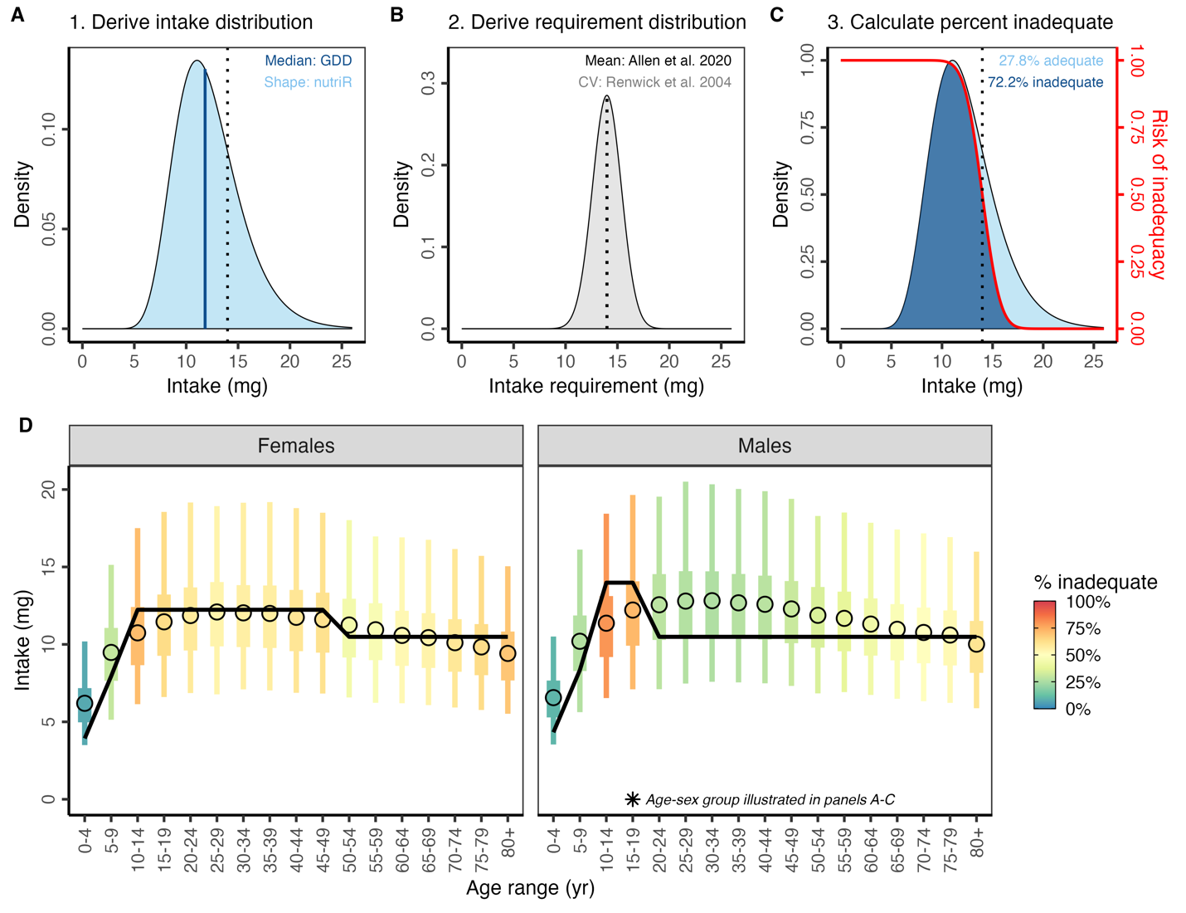**Figure 1.** A conceptual illustration of our methods for estimating the prevalence of inadequate micronutrient intakes using iron intakes in Kazakhstan as an example. The top row illustrates the procedure for males 15-19 years-old and the bottom row illustrates the results for all age-sex groups. First, we derive a skewed (gamma or log-normal) intake distribution, where the median (blue line) of distribution is drawn from the GDD and the shape of the distribution is drawn from the nutriR database (**panel A**). Second, we derive a normal requirement distribution, where the mean of the distribution is drawn from Allen et al.[24](https://www.zotero.org/google-docs/?SYno6W) and the standard deviation of the distribution is derived assuming a coefficient of variation (CV) of 0.25 for vitamin B12 and 0.10 for all other nutrients based on Renwick et al.[32](https://www.zotero.org/google-docs/?W3LNGj) (**panel B).** Finally, we derive the percent inadequate intake by intersecting these two distributions using the probability approach (**panel C**). We calculate the number of people with inadequate intakes using population estimates from the World Bank.[26](https://www.zotero.org/google-docs/?uWzmgV) In panels A-C, the vertical dotted line indicates the average requirement. We repeat this process for every age-sex group as illustrated in **panel D**. In panel D, the color of the intake distribution lines indicates the prevalence of inadequate intakes. The point represents the median intake based on GDD. The thick line represents the inner 50% of the intake distribution and the thin line represents the inner 95% of the intake distribution. The black line shows the sex- and age-specific average requirements.

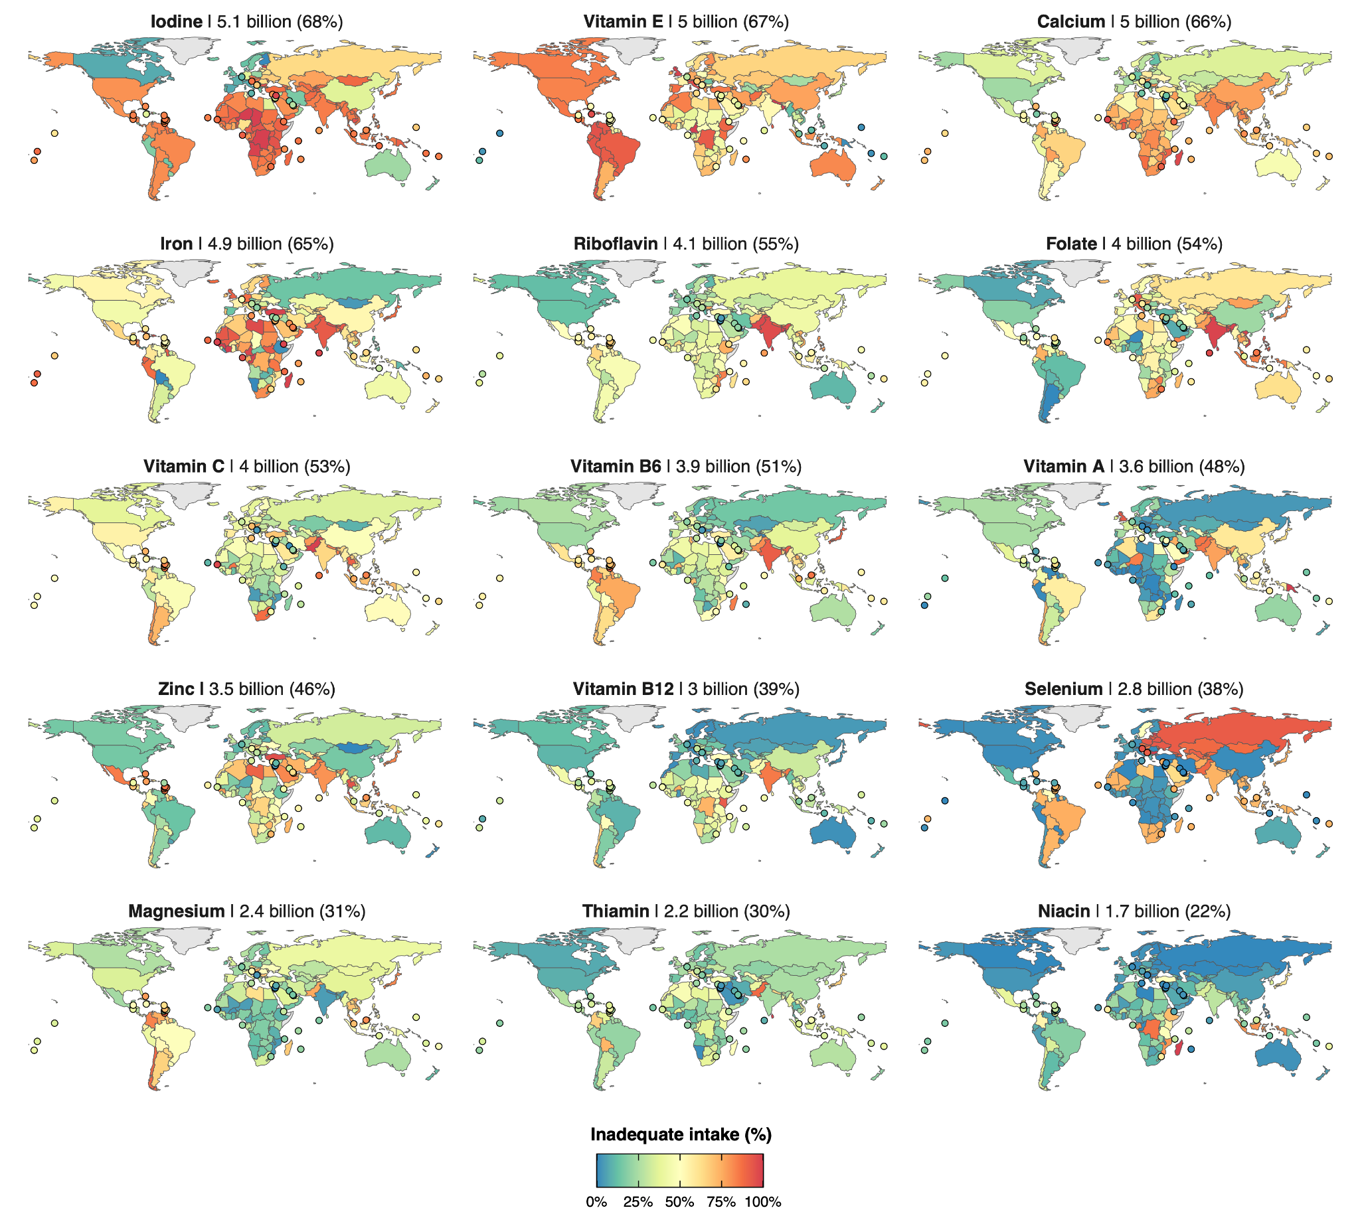**Figure 2.** Estimated prevalence of intake inadequacies by country and nutrient in 2018. The estimated number and proportion of the global population with inadequacies is labeled inside each map. Countries with land areas less than 25,000 km2 are shown as points to increase visibility.

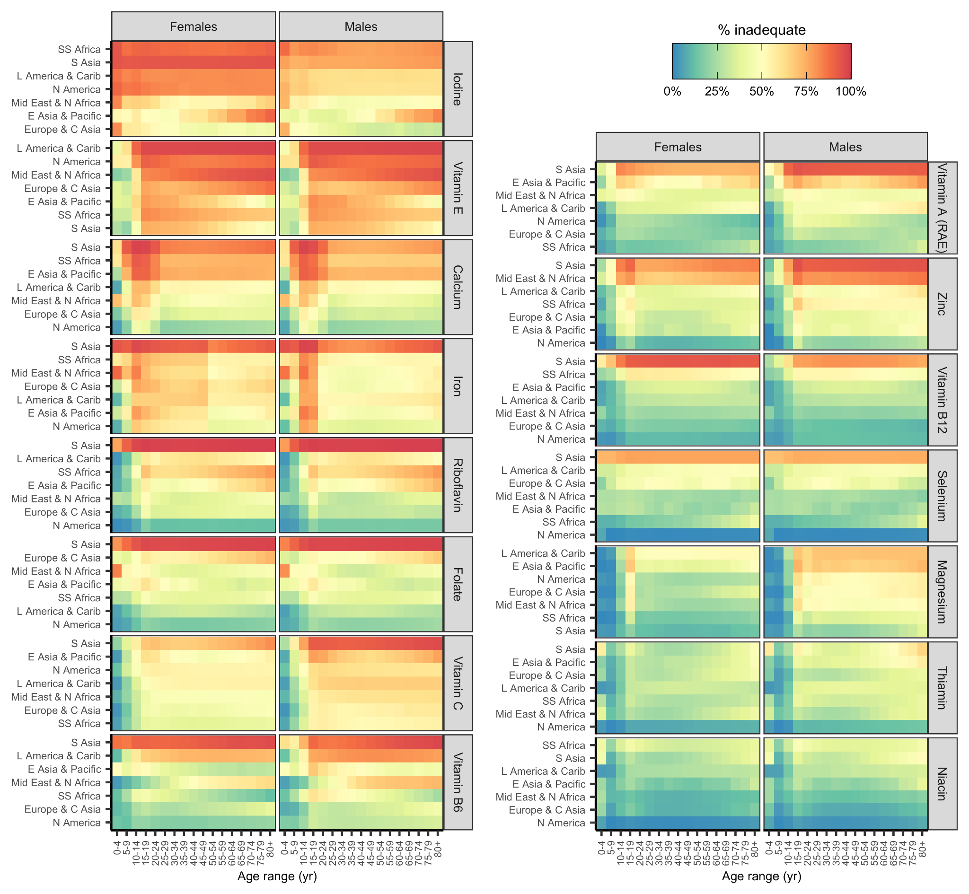**Figure 3.** Prevalence of intake inadequacies by World Bank region and nutrient in 2018. Nutrients and regions are arranged in order of decreasing prevalence of inadequate intakes. Region abbreviations: S=South, N=North, C=Central, SS=Sub-Saharan, Mid=Middle, L=Latin, Carib=Caribbean, NZ=New Zealand. See **Figure S11** for a map of the World Bank regions.

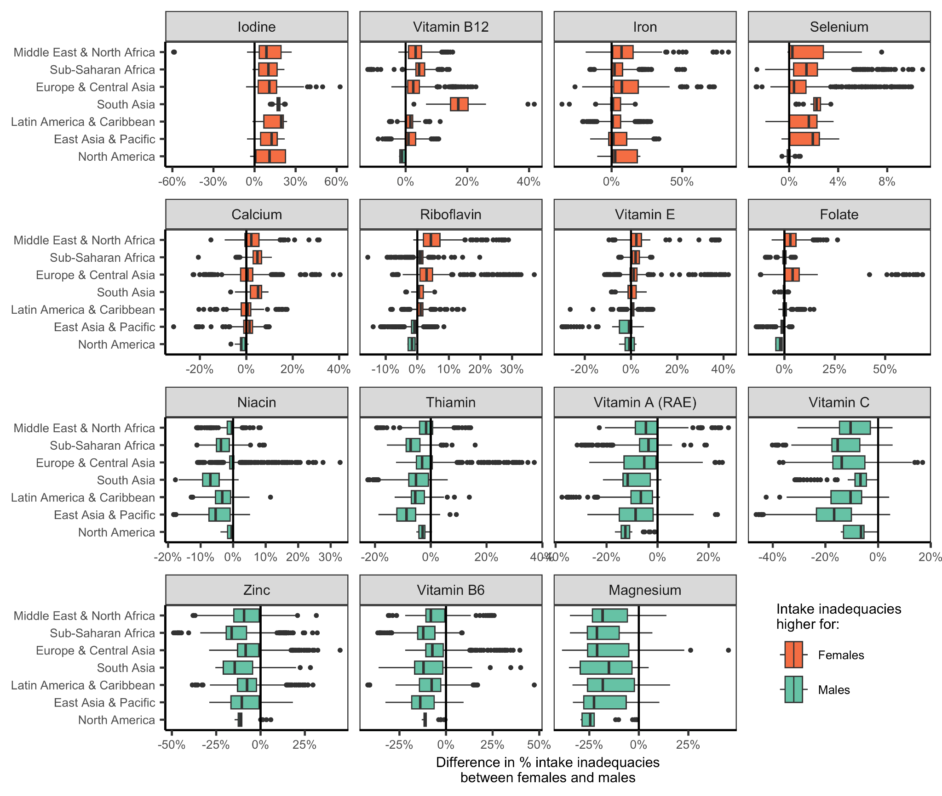**Figure 4.** Distribution of subnational differences in the prevalence of intake inadequacies between females and males by World Bank region. Values greater than zero indicate higher prevalence of intake inadequacies in females relative to males in the same country and age group. Values less than zero indicate higher prevalence of intake inadequacies in males relative to females in the same country and age group. In the boxplots, the solid line indicates the median, the box indicates the interquartile range (IQR; 25th to 75th percentiles), the whiskers indicate 1.5 times the IQR, and the points beyond the whiskers indicate outliers. See **Figure S11** for a map of the World Bank regions.

## Supplemental Tables and Figures

**Table S1.** Nutrients included in analysis (AR=average requirement; IOM=U.S. Institute of Medicine; EFSA=European Food Safety Authority).

|  |  |  |  |  |  |
| --- | --- | --- | --- | --- | --- |
|  |  |  |  | **Prevalence of inadequacies** |  |
| **Type** | **Nutrient** | **Units** | **AR source** | **(billions of people)** | **% of people** |
| Vitamin | Vitamin E | mg | IOM | 5.0 | 66.9% |
| Vitamin | Riboflavin (vitamin B2) | mg | EFSA | 4.1 | 54.5% |
| Vitamin | Folate (vitamin B9) | µg DFE | EFSA | 4.1 | 53.8% |
| Vitamin | Vitamin C | mg | EFSA | 4.0 | 53.3% |
| Vitamin | Vitamin B6 (pyridoxine) | mg | EFSA | 3.9 | 51.5% |
| Vitamin | Vitamin A (RAE) | µg DFE | EFSA | 3.6 | 47.9% |
| Vitamin | Vitamin B12 (cobalamin) | ug | IOM | 3.0 | 39.4% |
| Vitamin | Thiamin (vitamin B1) | mg | IOM | 2.2 | 29.7% |
| Vitamin | Niacin (vitamin B3) | mg | IOM | 1.7 | 22.1% |
| Mineral | Iodine | ug | IOM | 5.1 | 67.5% |
| Mineral | Calcium | mg | EFSA | 5.0 | 66.3% |
| Mineral | Iron | mg | EFSA | 4.9 | 64.8% |
| Mineral | Zinc | mg | EFSA | 3.5 | 46.2% |
| Mineral | Selenium | ug | IOM | 2.8 | 37.6% |
| Mineral | Magnesium | mg | IOM | 2.4 | 31.4% |

**Table S2.** Dietary factors included in the Global Dietary Database (GDD). *** animal-source food used to derive average requirements for iron (see **Figures S7 and S9**).

|  |  |  |
| --- | --- | --- |
| **Type** | **Factor** | **Units** |
| Vitamins | Folate | µg DFE |
| Vitamins | Vitamin A (RAE) | µg RAE |
| Vitamins | Vitamin B1 | mg |
| Vitamins | Vitamin B12 | µg |
| Vitamins | Vitamin B2 | mg |
| Vitamins | Vitamin B3 | mg |
| Vitamins | Vitamin B6 | mg |
| Vitamins | Vitamin C | mg |
| Vitamins | Vitamin D | µg |
| Vitamins | Vitamin E | mg |
| Minerals | Calcium | mg |
| Minerals | Iodine | µg |
| Minerals | Iron | mg |
| Minerals | Magnesium | mg |
| Minerals | Potassium | mg |
| Minerals | Selenium | µg |
| Minerals | Zinc | mg |
| Fatty acids | Monounsaturated fatty acids | % of total kcal |
| Fatty acids | Plant omega-3 fatty acids | mg |
| Fatty acids | Saturated fat | % of total kcal |
| Fatty acids | Seafood omega-3 fatty acids | mg |
| Fatty acids | Total omega-6 fatty acids | % of total kcal |
| Macronutrients | Added sugars | % of total kcal |
| Macronutrients | Dietary cholesterol | mg |
| Macronutrients | Dietary fiber | g |
| Macronutrients | Dietary sodium | mg |
| Macronutrients | Total carbohydrates | % of total kcal |
| Macronutrients | Total protein | g |
| Beverages | Coffee | cups |
| Beverages | Fruit juices | g |
| Beverages | Sugar-sweetened beverages | g |
| Beverages | Tea | cups |
| Beverages | Total milk | g |
| Foods | Beans and legumes | g |
| Foods | Cheese | g |
| Foods | Eggs *** | g |
| Foods | Fruits | g |
| Foods | Non-starchy vegetables | g |
| Foods | Nuts and seeds | g |
| Foods | Other starchy vegetables | g |
| Foods | Potatoes | g |
| Foods | Refined grains | g |
| Foods | Total processed meats *** | g |
| Foods | Total seafoods *** | g |
| Foods | Unprocessed red meats *** | g |
| Foods | Whole grains | g |
| Foods | Yoghurt (including fermented milk) | g |

**Table S3.** Mapping Global Dietary Database (GDD) age groups to match the World Bank (WB)[26](https://www.zotero.org/google-docs/?mUQfjW) age groups.

|  |  |
| --- | --- |
| **GDD age group** | **WB age group** |
| 0-11 mo | 0-4 yr |
| 12-23 mo | 0-4 yr |
| 2-5 yr | 0-4 yr |
| 6-10 yr | 5-9 yr |
| 11-14 yr | 10-14 yr |
| 15-19 yr | 15-19 yr |
| 20-24 yr | 20-24 yr |
| 25-29 yr | 25-29 yr |
| 30-34 yr | 30-34 yr |
| 35-39 yr | 35-39 yr |
| 40-44 yr | 40-44 yr |
| 45-49 yr | 45-49 yr |
| 50-54 yr | 50-54 yr |
| 55-59 yr | 55-59 yr |
| 60-64 yr | 60-64 yr |
| 65-69 yr | 65-69 yr |
| 70-74 yr | 70-74 yr |
| 75-79 yr | 75-79 yr |
| 80-84 yr | 80+ yr |
| 85-89 yr | 80+ yr |
| 90-94 yr | 80+ yr |
| 95+ yr | 80+ yr |

**Table S4.** Key assumptions made throughout analysis.

|  |  |
| --- | --- |
| **#** | **Assumption** |
| 1 | Intake distribution shapes for subnational groups without nutriR data can be borrowed, in order of preference, from the nearest age-sex group, the opposite sex, or the country with the most similar diet. |
| 2 | When intake distributions shift higher or lower, the median changes but the shape remains the same. |
| 3 | The requirement distribution for Vitamin B12 has a coefficient of variation (CV) of 0.25 and the requirement distributions of all other nutrients have CVs of 0.10. |
| 4 | We do not quantitatively evaluate the impact of fortified foods. |

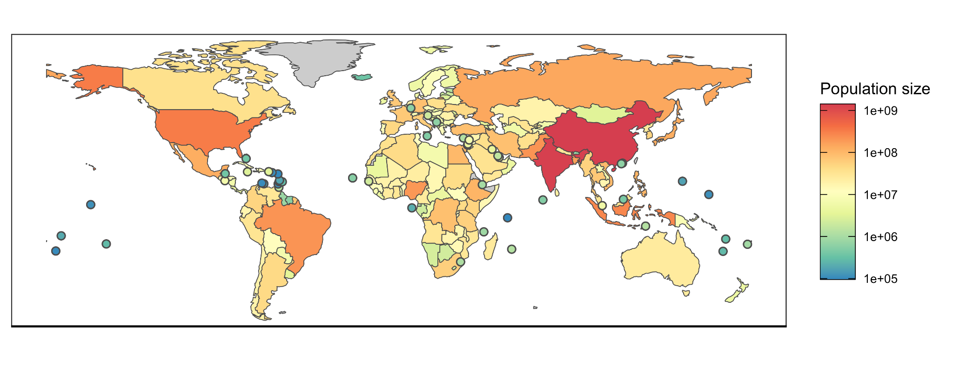**Figure S1.** Human population size in 2018 from the World Bank.[26](https://www.zotero.org/google-docs/?b9Sl9Z) Countries with land areas less than 25,000 km2 are shown as points to increase visibility.

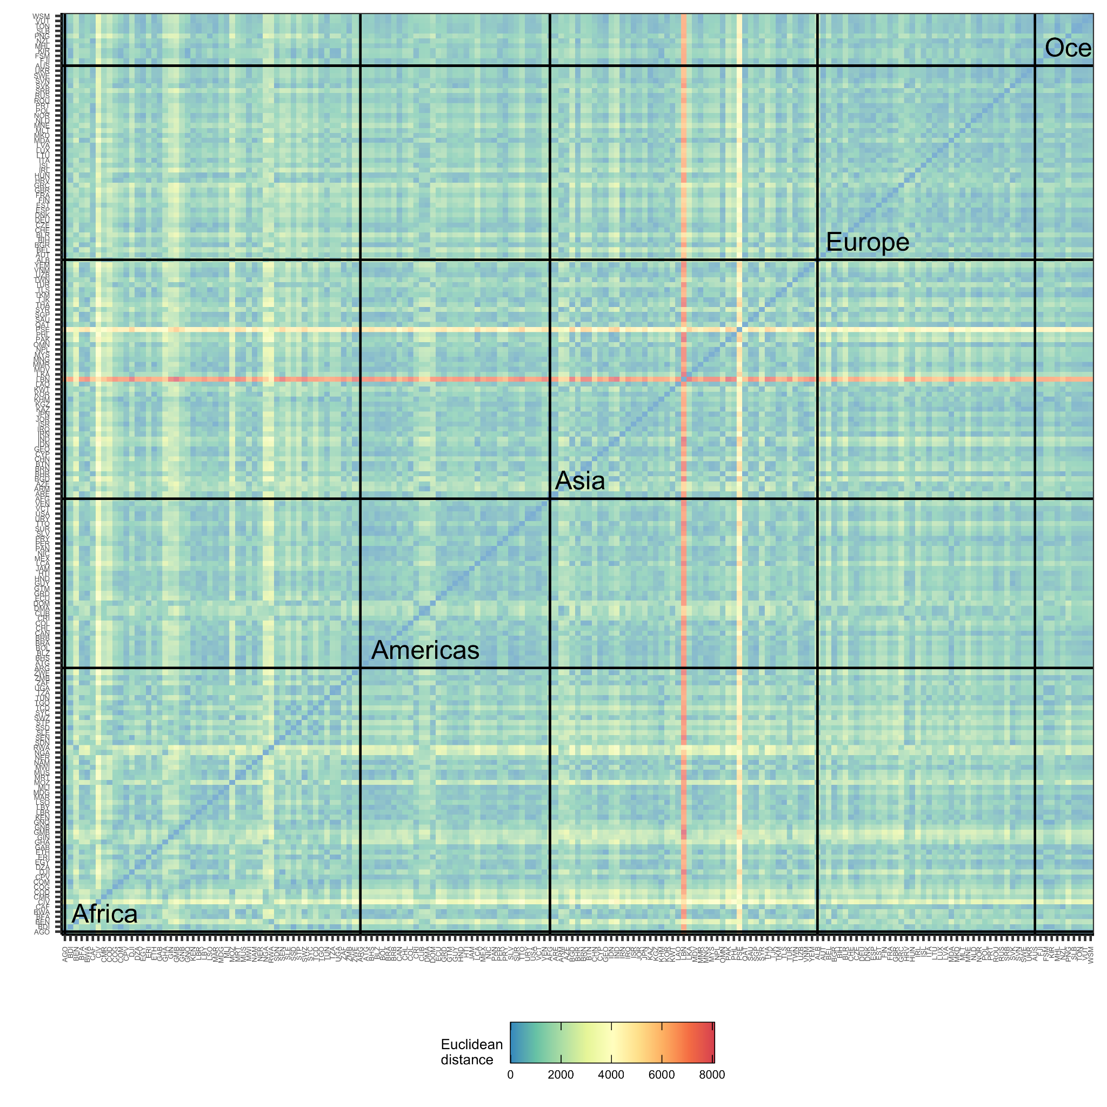**Figure S2.** The Euclidean distance between the nutrient intakes of the 185 countries with GDD intake estimates. Euclidean distances were calculated using national averages of vitamin and mineral intakes. Small Euclidean distances indicate countries with very similar national-scale nutrient intakes and large Euclidean distances indicate countries with very different national scale nutrient intakes. See **Table S2** for a list of the vitamins and minerals included in this calculation. Countries are grouped by continent. Palestinian territories (PSE) and Lebanon (LBN) have dramatically different nutrient intakes than every other country (the horizontal and vertical red bands represent extremely far Euclidean distance).

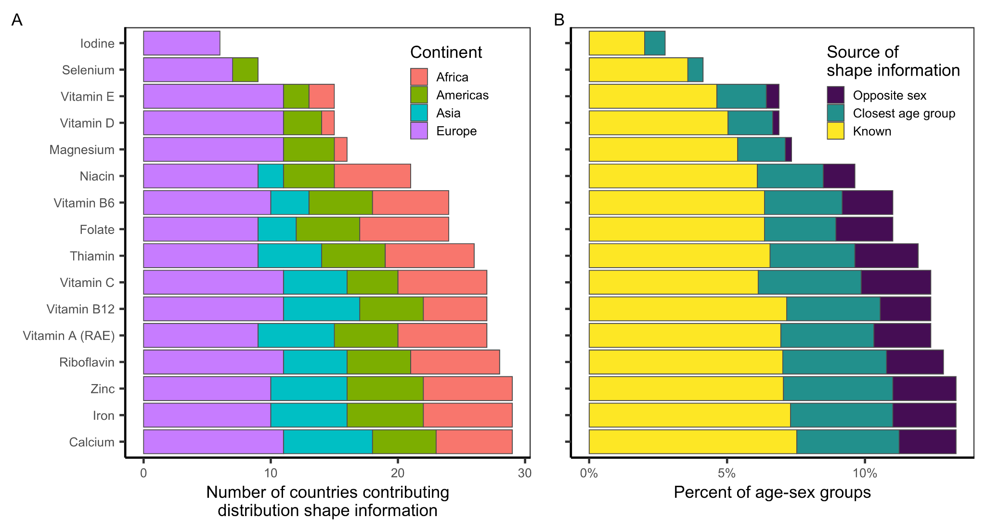**Figure S3.** The availability of distribution shape information for building usual intake distributions for all of the evaluated subnational age-sex groups. Panel A shows the number of countries contributing shape information and Panel B shows the percentage of age-sex groups with known shape information or with shape information borrowed from the closest age group or the opposite group. Shape information for the remaining percentage is borrowed from the corresponding age-sex group from the most similar country (see methods).

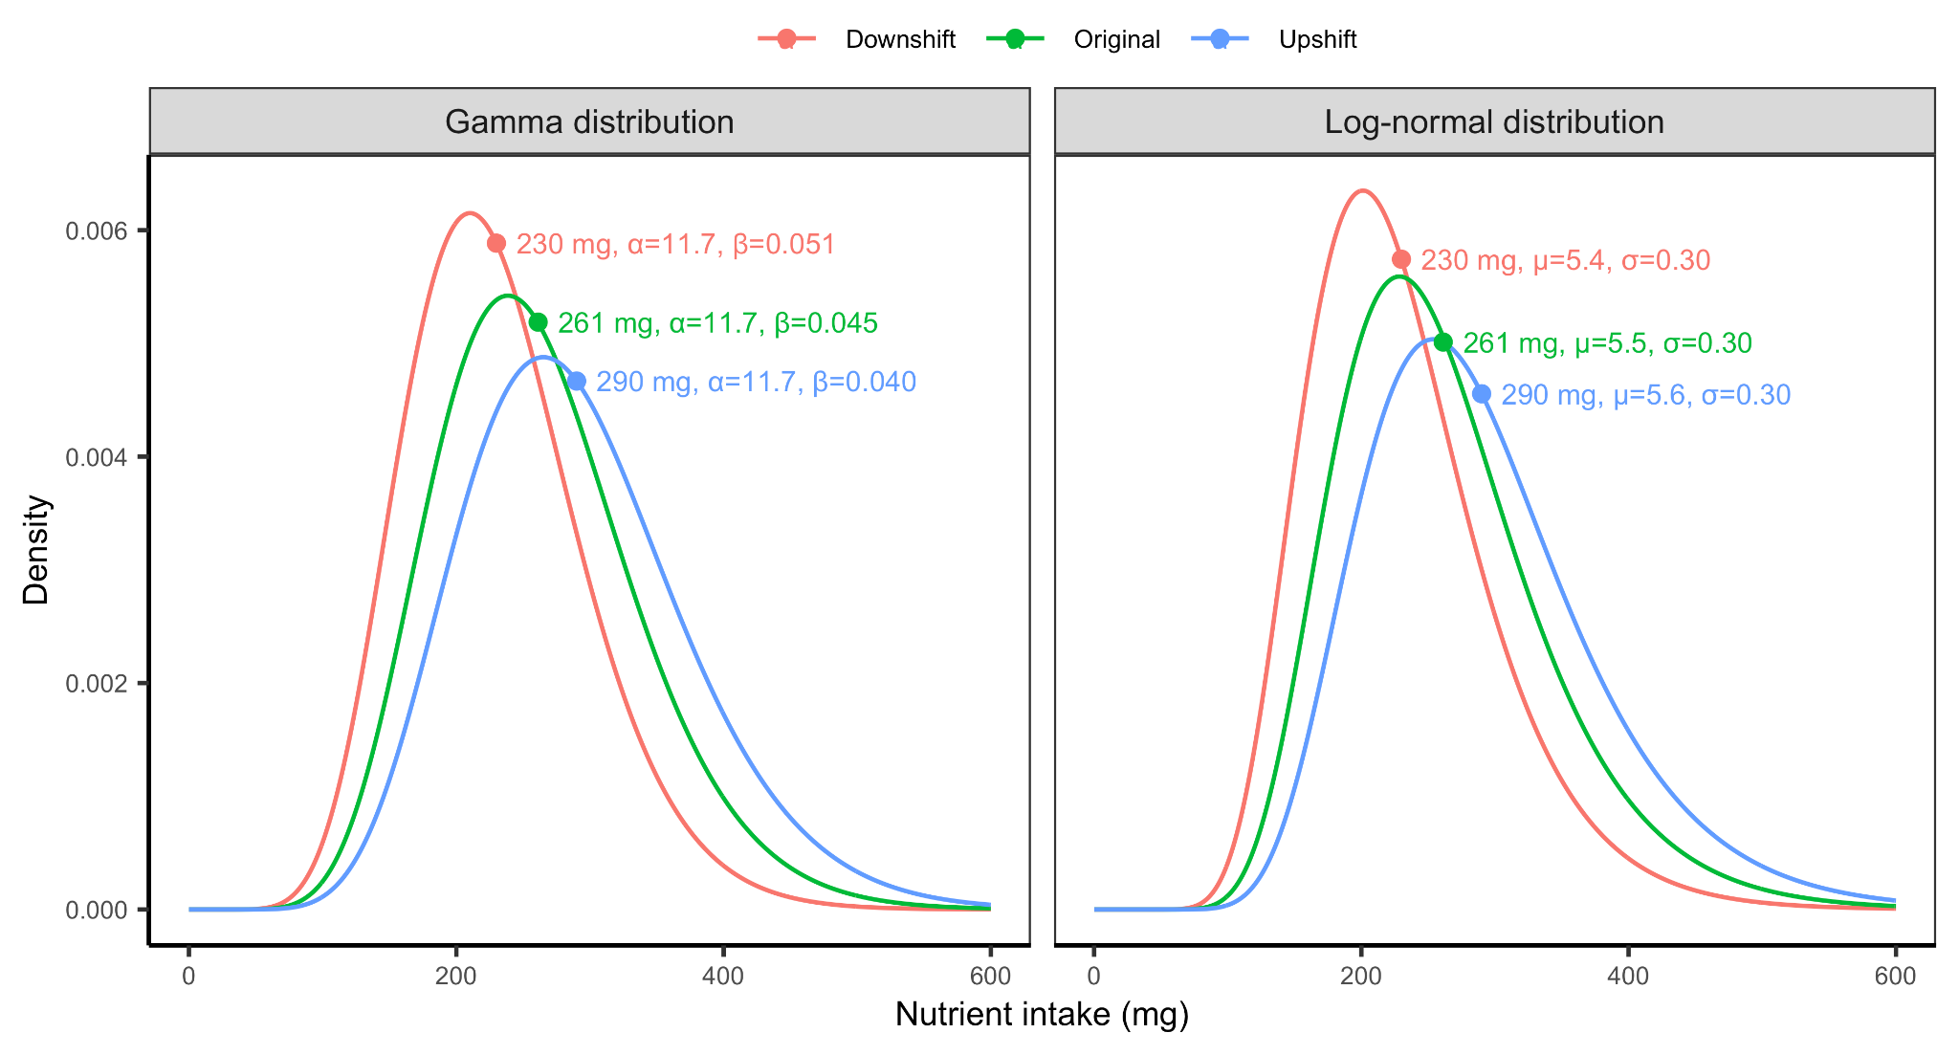**Figure S4.** Conceptual illustration of the methods used to shift the distributions defined by the matched shape parameters to match the Global Dietary Database median for each subnational group. Distributions were shifted by maintaining the variability parameter (*α* and *σ* for the gamma and log-normal distributions, respectively) and shifting the centrality parameter (*β* and *µ* for the gamma and log-normal distributions, respectively).

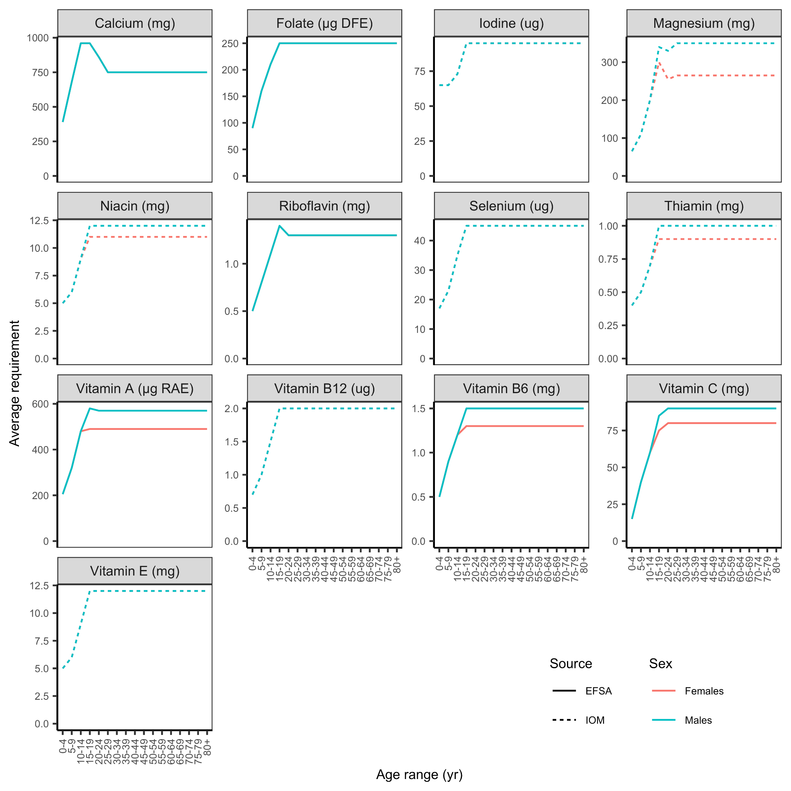**Figure S5.** Harmonized average requirements (H-ARs) from Allen et al.[24](https://www.zotero.org/google-docs/?Vqb6bE) for 13 of 15 nutrients evaluated in this paper. Males and females have identical average requirements for calcium, folate, iodine, riboflavin, selenium, vitamin B12, and vitamin E. Average requirements for iron and zinc are shown in **Figures S6 and S7**, respectively. Harmonized average requirements are drawn from the U.S. Institute of Medicine (IOM) and European Food Safety Authority (EFSA).

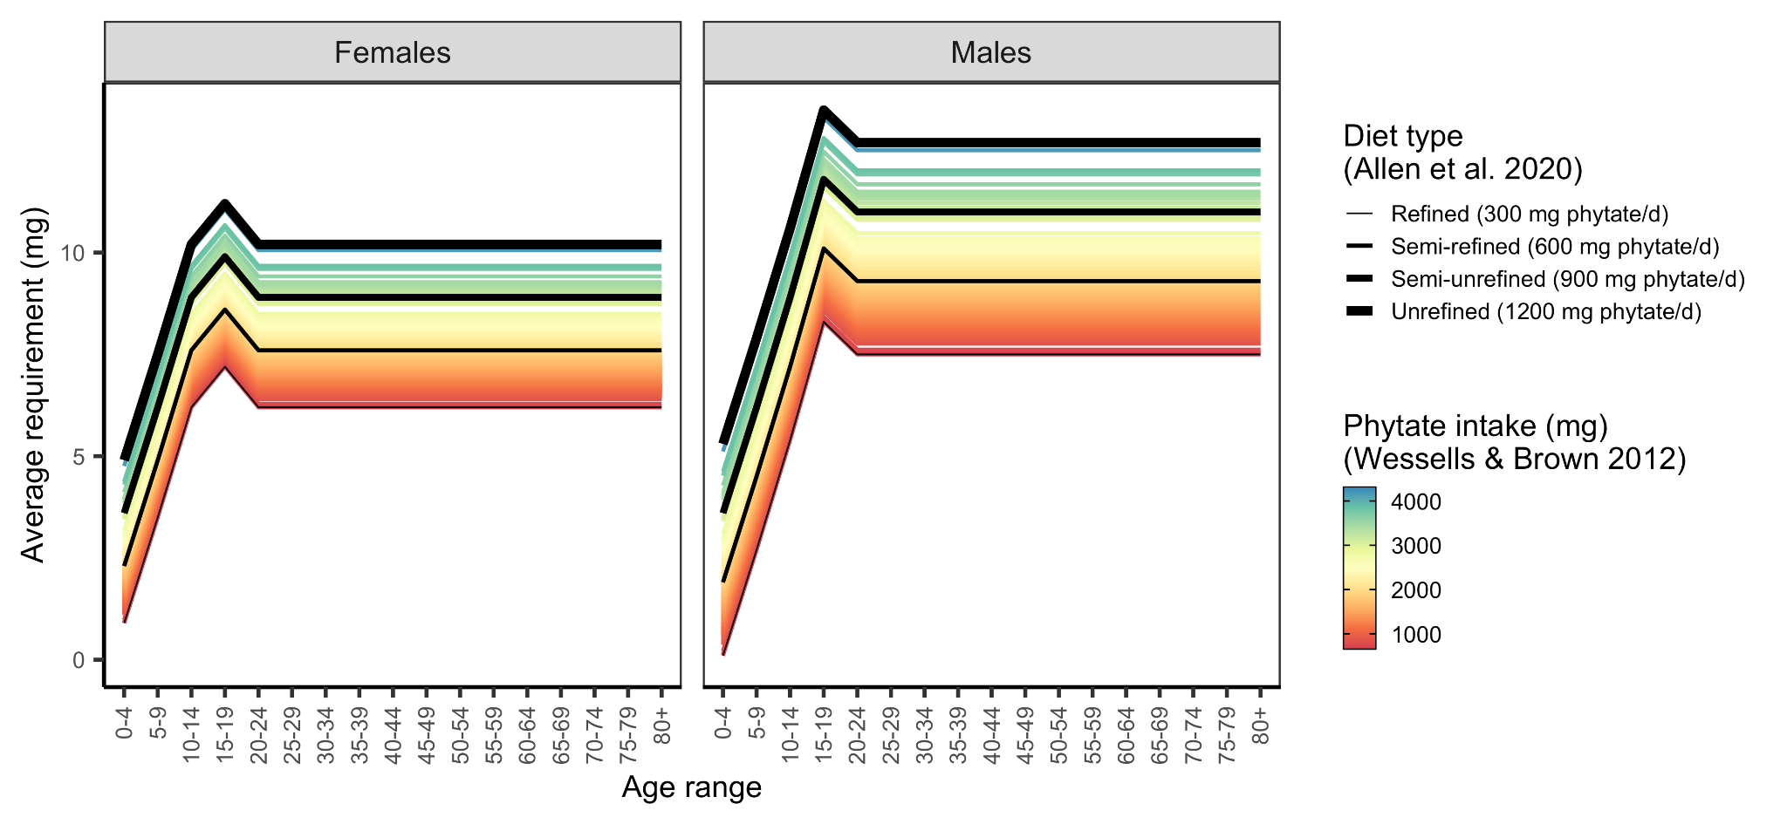**Figure S6.** Average requirements for zinc by age-sex group based on diet type, as specified by Allen et al.[24](https://www.zotero.org/google-docs/?t9v3wA), and 2005 phytate intake, as estimated by Wessells and Brown[36](https://www.zotero.org/google-docs/?TzuX3R). The colored lines represent the requirements estimated for each country.**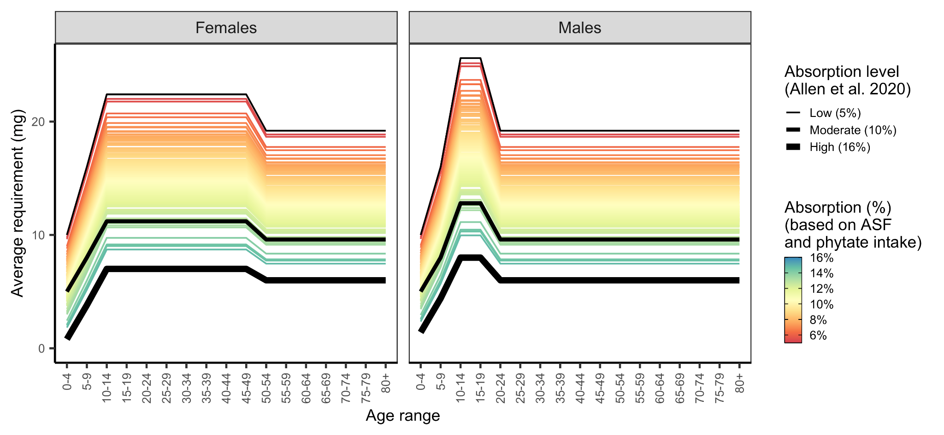Figure S7.** Average requirements for iron by age-sex group based on country-specific absorption levels. Countries were assigned an absorption level based on their phytate (**Figure S8**) and animal-source food (ASF) intakes (i.e., sum of unprocessed red meat, processed meat, seafood, and egg intakes) (**Figure S9**). See **Figure S10** for a map of absorption levels.

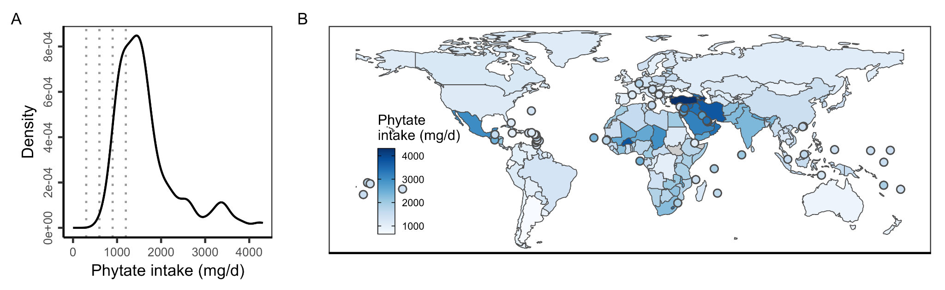**Figure S8.** Phytate intake in 2005 as estimated in Wessells and Brown[36](https://www.zotero.org/google-docs/?ghLy8L). In (A), vertical lines mark the phytate intake reference points used to specify average requirements in Allen et al.[24](https://www.zotero.org/google-docs/?HxTVxg). In **(B)**, countries with land areas less than 25,000 km2 are shown as points to increase visibility.

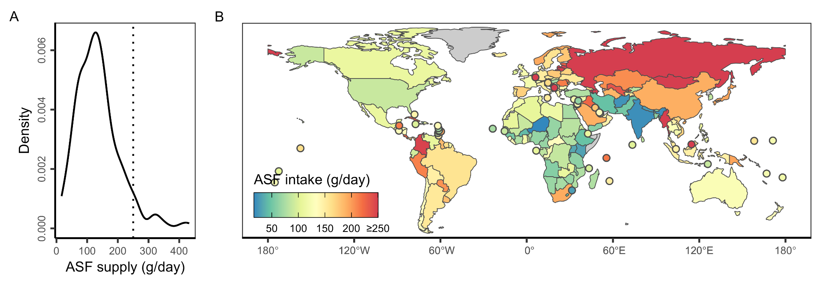**Figure S9.** Average country-level animal-source food (ASF) intake (i.e., sum of unprocessed red meat, processed meat, seafood, and egg intakes) in the Global Dietary Database.[20](https://www.zotero.org/google-docs/?JxevOm) In **(B)** ASF supply is capped at 250 g/day to ease visualization (vertical line in **A**).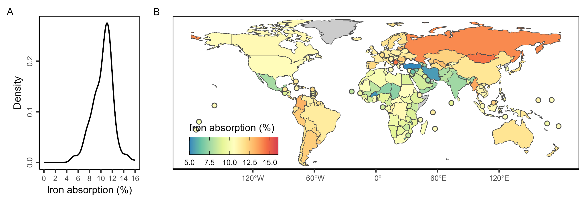

**Figure S10.** Estimated iron absorption levels for each country. Iron absorption levels were estimated based on country-specific phytate (**Figure S8**) and animal-source food (ASF) intakes (i.e., sum of unprocessed red meat, processed meat, seafood, and egg intakes) (**Figure S9**).

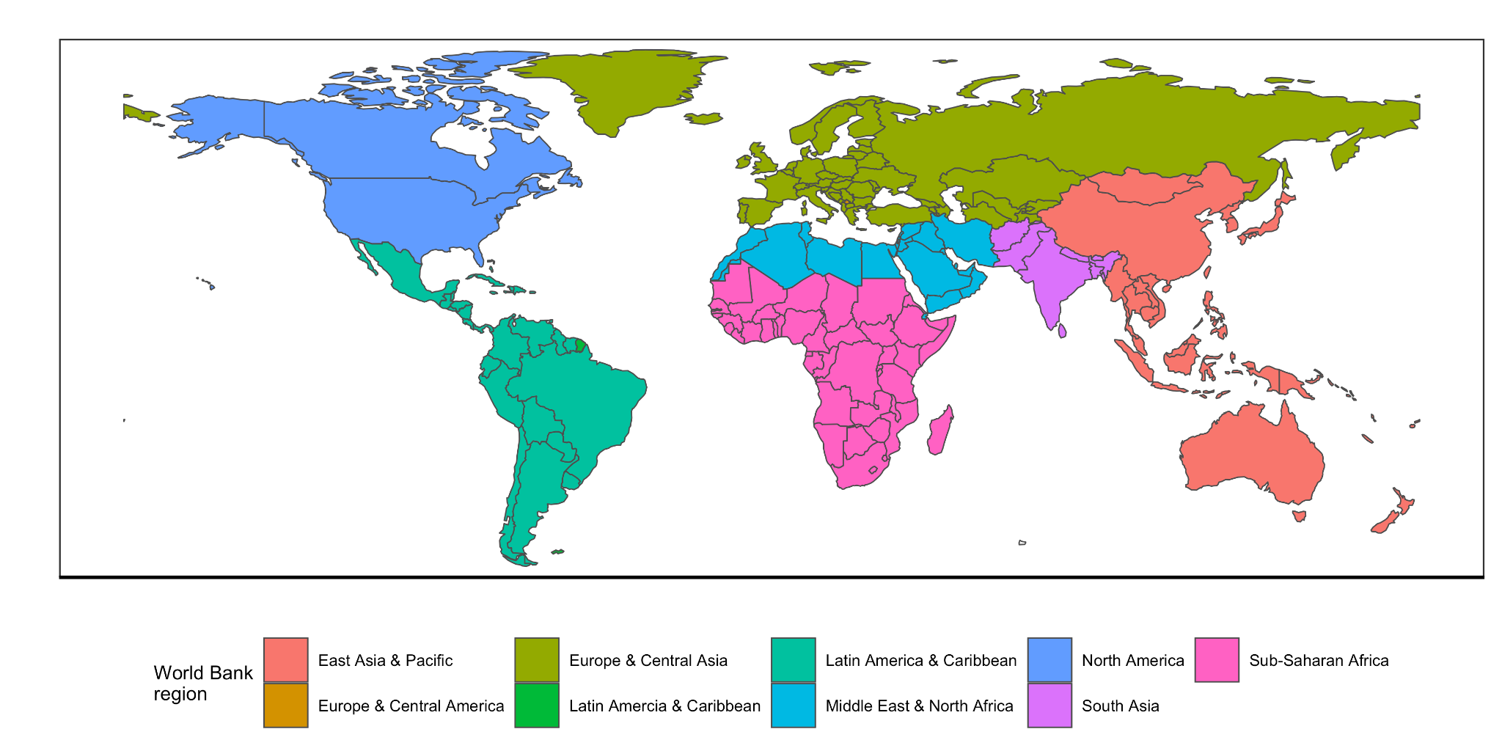

**Figure S11.** World Bank regions used to group results in the main text analysis.